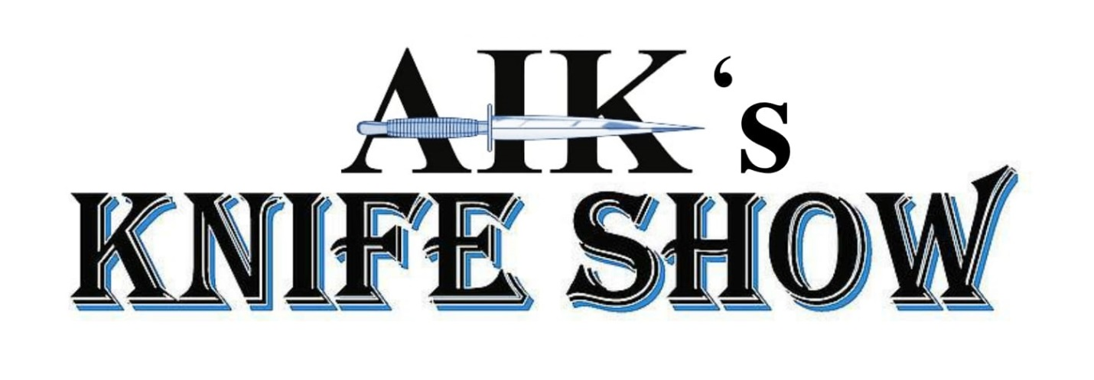

www.aik-knifeshow.com
adamsknifeworks.com@gmail.com | 618-656-9868

Dear Knife Dealer/Maker/Supplier,
You are invited to AIK’s Fifth Annual Knife Show which will be held July 17 and 18 in Washington, MO at the Elks Lodge. Washington, MO is on the south side of the Missouri River, less than an hour just west of St Louis off of I-44 (Ten miles from the Six Flags exit.) It has approximately 14,000 people with an additional 25,000 within a 10-mile radius. (Washington is part of the St Louis Metro Region which also encompasses 2.1 Million people. This includes the area west of St. Louis in Missouri and East of St. Louis in Illinois.) Missouri's third largest fair is held here and Washington is a really nice town with a friendly community.
The Elks Lodge is an excellent facility that is easy to find with plenty of parking, it features easy loading and unloading, excellent lighting, and will have up to 125 8 ft tables set up in their “open floor plan” showroom. Tables are only $75 with a maximum of 5 tables per dealer. Dealer set up will be Friday Noon to 5pm or Saturday from 8am to 9am. To set up your table reservation or if you have any questions please call 618-656-9868 and ask for Beth or Crystal. To ensure your tables are held for this show payment is required in advance. We will no longer be accepting “pay at the door” reservations. For your convenience we are accepting checks and also accepting MasterCard, Visa, AmEx, and Discover.
Please make checks payable and remit to:
AIK
8710 Rosewood Hills Dr,
Edwardsville, IL 62025

The Show is being promoted by AIK – Adams International Knifeworks (Edwardsville, IL) We have been in the knife business since 1987 and attend several shows every year and know what it takes to promote a successful show. Our goal is to create a great buying crowd for the dealers and for the public to have an enjoyable and educational experience, so that the hobby of knife collecting and making can continue. We hope to offer a unique mixture of dealers from both the upper and lower Midwest including some unique suppliers and knifemaking equipment providers that would appeal to both the knifemaker and to the public. Our ultimate goal is to have a high caliber knife show with some of the finest makers and dealers while also building up the show’s reputation as being a high-end knife show. The show is being heavily promoted online and via social media as well as other outlets. Visit us at aik-knifeshow.com.
The Elks Lodge is located at 1459 W 5th St, Washington, MO, 63090. If you are coming from the St. Louis area you will travel west on I-44 and take exit 251 to MO-100 W towards Washington then make a right on MO-100 and go approximately 11 miles, then turn right on to Clay Street. Travel on Clay St for ½ mile and then turn right on to W 5th St. The Elks Lodge will be on the right. If you are traveling East on I-44 towards St. Louis you will take exit 251 to MO100 W towards Washington and turn left towards MO-100 W, and travel approximately 11 miles on MO-100 W, then turn right on to Clay Street. Travel on Clay St for ½ mile and then turn right on to W 5th St. The Elks Lodge will be on the right. Show hours are Saturday July 24th from 9am to 5pm, Sunday July 25th 9am to 2pm. With show set up on Friday from Noon to 5pm and Saturday from 8am to 9am. (keep in mind early bird shoppers will be allowed in on Saturday.)
Hotels we recommend:
Super 8 | (636) 390-0088 | 2081 Eckelkamp Ct, Washington, MO 63090 | 2.6 mi
Best Western | (636) 390-8877 | 2621 E Fifth St, Washington, MO 63090 | 3.8 mi
Super 8 | (636) 583-8808 |1015 E Main St, Union, MO 63084 | 8.9 mi
Rooms fill up very quickly, please do not delay when booking your room. Any questions or concerns can be answered at 618-656-9868. All this information can also be found on aik-knifeshow.com as well.
We look forward to hear from you and can’t wait to see you at the show!
Best Regards,
AIK- Adams International Knifeworks Team

ADMISSION ONLY $5! FREE PARKING! GRAND PRIZE DRAWING!
EARLY BIRD PASSES AVAILABLE AT THE DOOR FOR $15!

<<<<<<<<<<<<<<<<<<<<<<<<<<<<<<<<<<<<<<<<<<<<<<<<<<<<<<<<<<<<<<<<<<<<<>>>>>>>>>>>>>>>>>>>>>>>>>>>>>>>>>>>>>>>>>>>>>>>>>>>>>>>>>>>>>>>>>>>>>>>>
5th Annual Summer Show!

<<<<<<<<<<<<<<<<<<<<<<<<<<<<<<<<<<<<<<<<<<<<<<<<<<<<<<<<<<<<<<<<<<<<<>>>>>>>>>>>>>>>>>>>>>>>>>>>>>>>>>>>>>>>>>>>>>>>>>>>>>>>>>>>>>>>>>>>>>>>>
July 17 & 18, 2021
Washington, MO Elks Lodge
1459 W 5th St, Washington, MO 63090

Sunday
July 18th
^{9:00 am to 2:00 pm}
Saturday
July 17th
^{9:00 am to 5:00 pm}
<<<<<<<<<<<<<<<<<<<<<<<<<<<<<<<<<<<<<<<<<<<<<<<<<<<<<<<<<<<<<<<<<<<<<>>>>>>>>>>>>>>>>>>>>>>>>>>>>>>>>>>>>>>>>>>>>>>>>>>>>>>>>>>>>>>>>>>>>>>>>

Hotel Information
Super 8 | (636) 390-0088 | 2081 Eckelkamp Ct, Washington, MO 63090 | 2.6 mi
Best Western | (636) 390-8877 | 2621 E Fifth St, Washington, MO 63090 | 3.8 mi
Super 8 | (636) 583-8808 | 1015 E Main St, Union, MO 63084 | 8.9 mi

Dealer Information: - up to 125 - 8ft Tables Available. Table Cost is $75.
Dealer Set Up: Friday Set Up from 1pm - 5 pm.

For More Table Reservation Information Contact Crystal or Beth at 618-656-9868.
Open to the Public from 9am-5pm Saturday and 9am-2pm Sunday.
Table Space will only be held if you Pay in advance. No more “Pay at the Door” or “Pay the day of the show” accepted.
If you don’t prepay then you don’t have tables. No cancellations accepted after July 15th 2020.
Reserving table space at the AIK Knife Show indicates you agree to the terms and conditions.

- - - - - - - - - - - - - - - - - - - - - - - - - - - - - - - - - - - - - - - - - - - - - - - - - - - - - - - - - - - - - - - - - - - - - - - - - - - - - - - - - - - - - - - - - - - - - - - - - - - - - - - - - - - - - - - - - - - - - - - - - - - - - - - - - - -

Please Reserve Tables @ $75 = I will be displaying %Factory %Custom %Antique Supplies
Name Phone Payment Must Accompany Reservation Form
Address City State Zip
Email Number of Badges
Make Reservation Payable to: AIK, 8710 Rosewood Hills Dr, Edwardsville, IL, 62025-7036

Visit us at www.aik-knifeshow.com

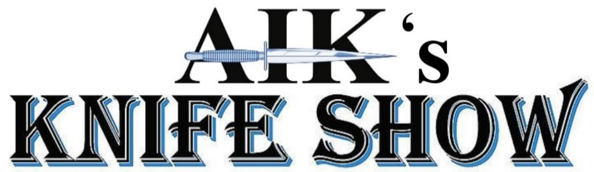

Show Exhibitor Rules

- Refunds for tables will be made only if notice of cancellation is received by the Show Director PRIOR to the specified date on the show application. After that deadline, table fees are forfeited and may not be applied to any future table fees. The Show Director is to be notified of LATE ARRIVALS or the table will be reassigned to someone else. Set up hours are Friday Noon to 5pm and on Saturday 8am to 9am.

- The Elks Lodge is a non-smoking facility. No alcoholic beverages will be allowed inside.

- Exhibitors are expected to know and observe all federal, state, and local laws pertaining to knives and related items, AIK Knife Show, and its directors and promoters assume no responsibility for any exhibitor’s failure to know or abide by such laws.

- BALLISTIC or PROJECTILE type knives are strictly prohibited from the premises of the show under ANY circumstances with NO exceptions.

- The “AIK Knife Show”, “Elks Club”, and its directors and promoters will not be responsible for any theft, accidental loss or injury, or damage to the exhibitor’s property while the exhibitor’s property is on the premises. The facility will be locked at night with an alarm system, security will be provided at the show.

- In order to maintain a uniform appearance to the show and in fairness to neighboring table holders, no table is to be raised from the original height.

- No signs fastened to walls. The “Elks Club” does not permit affixing of anything to walls, floors, ceilings or rooms with nails, staples, tape or any other substance. The cost of damages due to unauthorized or careless decorating will be assumed by you. Open flame candles are not allowed on premises. Pyrotechnics of any type are not allowed. All decorations will be removed at the end of event.

- No flea market items – this is a knife show. Most, if not all items, must be knives or knife related. Knife related items would include display boxes, handle material, knife making supplies, etc.

- Firearms may not be displayed, sold, or traded at this show.

- Decisions made by the Show Director and show staff are final.

- We will try to keep the number, size, and location configuration and configuration of the table layout the same, but may be subject to change from year to year at the discretion of the Show Director.

- No dogs other than registered leader dogs for the blind or service dogs are allowed in the show or Elks Lodge.

- Where applicable, you are responsible for reporting and paying all taxes related to this event.
Reserving table space at the AIK Knife Show indicates
agreement and acceptance with these rules.

